**Sandhopper National Championships**

**6th & 7th September 2025**

**Event Sailing Instructions (ESI)**

**Organised by Thorpe Bay Yacht Club in association with the**

**Sandhopper Class British Association**.

**1.** Rules

**1.1**. The regatta will be governed by the rules as defined in The Racing Rules of Sailing (RRS), the prescriptions of the RYA and the rules of the class, except as any of these are changed by the Notice of Race and these Sailing Instructions.

**1.2**. Thorpe Bay Yacht Club implements the RYA Racing Charter which requires competitors to sail and organisers to provide racing in compliance with the Charter, which can be found at the front of the RYA Racing Rules of Sailing.

**2.** **Notices to Competitors**

**2.1**. Notices will be posted on the class notice board located in the clubhouse lobby.

**3.** **Changes to Sailing Instructions**

**3.1**. Any change to the sailing instructions will be posted not less than 2 hours before the start of a race it affects, except that any change in the schedule of races will be posted by 20.00 hours on the day before it will take effect.

**4. Signals Made Ashore**

**4.1.** Signals made ashore will be displayed on the flagstaff in front of the clubhouse.

**4.2.** When Flag AP is displayed ashore, ‘one minute’ is replaced with 'not less than 30 minutes’ in race signal AP. This changes the Race Signals in the RRS.

**5. Schedule of Races**

**5.1.** Briefing at 08:30 a.m. on first floor of TBYC clubhouse.

Dates and times of races:

|  |  |  |  |
| --- | --- | --- | --- |
| Date | Race | Time | High Water |
| Saturday 6th September | Races 1, 2, 3 sailed back to back | Warning signal 09:55 | 12:23 BST |
| Sunday 7th September | Races 4, 5, 6 sailed back to back | Warning signal 10:25 | 13:04 BST |

**5.2.** When more than one race is scheduled for the same day, the warning signal for each succeeding race will be made as soon as practicable. To alert boats that another race or sequence of races will begin soon, the postponement signal “AP” will be displayed for at least two minutes. Once AP is lowered, the warning signal will be displayed one minute later.

**5.3** No more than 4 races shall be sailed in one day.

**5.4** Postponed or abandoned races may be re-sailed at any time during the event.

**6.** **Class flags**

**6.1.** The class warning signal will be NNO

**7. Racing Area**

**7.1.** The racing area is in the Thames Estuary to the south-west of the clubhouse.

**8. The Course**

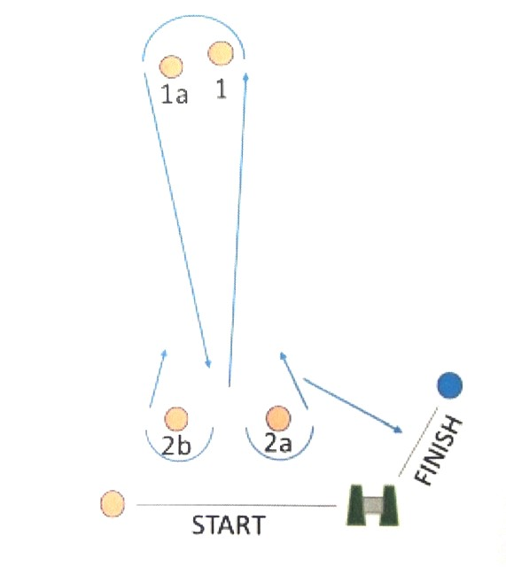

**8.1.** The course configuration and order of rounding marks will be as follows:

* 1 (port), 1a (port), 2a (port) **or** 2b (starboard). This is one round.
* Mark 1 is the intended windward mark with mark 1a as a Spreader mark.
* All boats must pass between mark 2a and 2b on each lap prior to the finish.
* Boats should continue with this course until the Shortened Course Flag “S” is displayed on the committee boat either by a flag, a board or both.
* Boats must then pass mark 2a to port and proceed to the finish line.

This changes RRS32.2.

**8.2.** The approximate magnetic bearing of Mark 1 from the midpoint of the start line may be displayed on a board on the Committee Boat before the warning signal.

**9.** **Marks**

**9.1.** Marks will normally be large orange or yellow inflatable buoys.

**10.** **Areas That Are Obstructions**

**10.1.** A patrol boat in close attendance to a craft or competitor in difficulty is an obstruction.

**11. The Start**

**11.1.** The start line is defined as the line between the halyard gantry on the Committee Boat displaying an orange flag and an outer starting line mark, normally of the orange or yellow inflatable type.

**11.2.** At the discretion of the Race Officer, a boat starting later than five minutes after her start signal may be scored ‘DNS’ without a hearing. This changes RRS Rule A4.

**11.3** The start sequence will be 5,4,1 -go.

**11.4** At the RO’s discretion the Black Flag or the U Flag may be used.

**12.** **Change of the Next Leg of the Course**

**12.1.** To change the next leg of the course, the race committee will move the original mark (or the finishing line) to a new position. Code Flag C and a red or green flag will be flown from either the committee boat or a support boat with repeating sound signals.

**13.** **The Finish**

**13.1.** The finishing line will be between the halyard gantry on the Committee Boat displaying an orange flag and the finish line mark.

**13.2.** The race committee may award a finishing position to a boat that is still racing by displaying to her from a race committee vessel (which may be in motion) flag W with one sound signal. A boat so notified is no longer required to sail the course, shall stop racing and shall return to the starting area, or return ashore if there is no more racing. A boat’s finishing position under this sailing instruction will be the position she would have received had she sailed the course and finished within any time limit, without gaining or losing any place. However, when two or more boats that are overlapped are notified, they will be scored as if they were tied. Failure to implement this rule shall not be grounds for redress. This changes RRS 28, 32, 35, A4 and A5.

**14. Race Organisation Committee**

**14.1** The Race Organisation Committee shall consist of Race Officers Allen Burrell and Paul Beasley, SCBA Chairman Kevin Whittle and TBYC Sandhopper Class Captain Clara Hunter.

**15. Time Limit**

**15.1** The time limit for a boat will be 20 minutes after the first boat sails the course and finishes, except that if the first boat fails to finish within 90 minutes of a valid start, the race will be abandoned.

**15.2** Boats failing to finish within the 20-minute time limit may, at the Race Committee’s discretion, be given a place based on their relative position at the 20 minute time limit or if this isn’t practical, from their previous lap following on from the results of those boats that did finish within the time limit. If neither of these options is practicable the boat will be scored DNF without a hearing. This changes rule 35, A4 and A5.

**16. Protests and Requests for Redress**

**16.1** Protests shall be written on forms available on request to the Race Committee and delivered to a member of the Race Committee within 90 minutes of the last boat of her class finishing the last race of the day.

**16.2** A schedule of protest hearings will be displayed on the official notice board within 2 hours of the finish of the last race of the day. Further protest hearings may be added to the schedule. This is the notice under RRS 63.2.

**16.3** The Exoneration Penalty and the Advisory Hearing and RYA Arbitration procedures of the RYA Rules Disputes procedures shall apply. The outcome of an RYA Arbitration can be referred to a protest committee, but an arbitration cannot be reopened or appealed. See the Official Notice Board for details.

**17. Scoring**

**17.1** Two races are required to be completed to constitute a National Championship series.

**17.2** (a) When fewer than 5 races have been completed, a boat’s series score will be

the total of her race scores.

(b) When 5 or 6 races have been completed, a boat’s series score will be the

total of her race scores excluding her worst score.

**18. Safety Regulations**

**18.1** It is the responsibility of the helmsman of each yacht to ensure that its departure for racing and its subsequent return are recorded on the Declaration Form provided at the top of the slipway or in the nearby Bosun’s Hut, whether or not the yacht starts or completes a race. Helmsmen must sign-off on the Declaration Form within one hour of coming ashore, within one hour of finishing the race, or within one hour of finishing the last race of the day if races are sailed back-to-back. If more than one race is scheduled helmsmen must sign-off separately for each race they completed or indicate DNS or DNF as appropriate. Failure to sign off on the Declaration Form will result in disqualification.

**18.2** RRS40 is changed, flag Y will not be used. Competitors shall wear personal flotation devices at all times whilst afloat, except briefly while changing or adjusting clothing or personal equipment as prescribed in rule 40. Wetsuits or dry suits are not adequate personal buoyancy.

**19. Replacement of Crew or Equipment**

**19.1** Substitution of crew will not be allowed without prior approval of the Race Organisation Committee.

**19.2** The same number of persons shall be on board for all races.

**19.3** The individual identified on the official entry form as the boat’s helm shall be on board for all races. Any change of helm from the person named on the official entry form will constitute a separate entry in terms of the overall result for the championship.

**20. Equipment and Measurement Checks**

**20.1** A boat or equipment may be inspected at any time for compliance with the class rules and sailing instructions. On the water, a boat can be instructed by a race committee equipment inspector or measurer to proceed immediately to a designated area for inspection.

**21. Support Boats**

**21.1** Team leaders, coaches and other support personnel shall stay outside areas where boats are racing from the time of the preparatory signal for the first start until all boats have finished or retired or the Race Committee signals a postponement, general recall or abandonment.

**22. Radio Communication**

**22.1** Except in an emergency, a boat that is racing shall not make voice or data transmissions and shall not receive voice or data communication that is not available to all boats.

**23. Disclaimer of Liability and Risk Statement**

**23.1** Competitors participate in the regatta entirely at their own risk, see RRS 4, Decision to Race. The organizing authority will not accept any liability for material damage or personal injury or death sustained in conjunction with or prior to, during or after the regatta.

**23.2** Rule 4 of the Racing Rules of Sailing states: “The responsibility for a boat’s decision to participate in a race or to continue racing is hers alone.” Sailing is by its nature an unpredictable sport and therefore involves an element of risk. By taking part in the event, each competitor agrees and acknowledges that:

a) They are aware of the inherent element of risk involved in the sport and accept responsibility for the exposure of themselves, their crew and their boat to such inherent risk whilst taking part in the event;

b) They are responsible for the safety of themselves, their crew, their boat and their other property whether afloat or ashore;

c) They accept responsibility for any injury, damage or loss to the extent caused by their own actions or omissions;

d) Their boat is in good order, equipped to sail in the event and they are fit to participate;

e) The provision of a race management team, patrol boats, umpires and other officials and volunteers by the organiser does not relieve them of their own responsibilities;

f) The provision of patrol boat cover is limited to such assistance, particularly in extreme weather conditions, as can be practically provided in the circumstances;

(g) They are responsible for ensuring that their boat is equipped and seaworthy so as to be able to face extremes of weather; that there is a crew sufficient in number, experience and fitness to withstand such weather; and that the safety equipment is properly maintained, stowed and in date and is familiar to the crew.