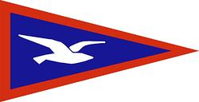

TBYC SAILING AGM – AGENDA
9th November 2021 @ Thorpe Bay Yacht Club

Start Time: 20:00

Agenda Item
- Apologies for absence
- Rear Com Report
- Fleets for 2023
- Courses for 2023
- Committee Boat
- Dutyman
- Trophy Races
- Class Captains | 2023 Class captain nominations / Volunteers
- AOB

