**TBYC Cadets**

Main Club Races for Cadets

**Sailing Instructions – KEY POINTS**

**SIGN ON** - Sign on and tick the column showing you are a Cadet Entry.

**SIGN OFF** at the end of the race.

**You do not** have a separate course for Trophy or Shore-box starts.

There is still a Cadet Class for results/trophies

**Course for Series Races:**

A1 (A small orange Inflatable Buoy)

C Buoy

D Buoy

Look at the **back** of the Committee Boat for

buoy numbers for C and D buoys



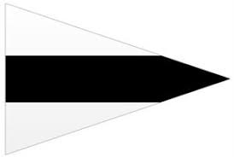**Starting Procedure**

Cadet Flag is:

Blue and White

White and Black

Your starting procedure begins

as the first class of boats start

(Published start time + 3 minutes) A sound signal accompanies the flags

**Finish as a Shortened Course Flag appears**



Finish early

Or

**Other flags**

White and Blue

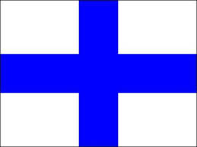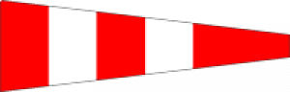

Red and Yellow

White and Blue

Red and White

Recall (Over the line)

Postponed