- Rules
  - The regatta will be governed by the ‘Rules’ as defined in Racing Rules of Sailing, the prescriptions of the RYA, the rules of the class, except if any of these are changed by these sailing instructions, and the supplementary sailing instructions.

- Entries
  - Eligibility - Eligible boats may be entered by completing registration with the organising authority as in the supplementary sailing instructions.
2.1.1 Competitors shall be no older than 19 on the 31st December 2021 for Youth Classes and under the age of 16 on the 31st December 2021 for Junior Classes. In the case of double handed boats all members must be within the age group above. In the case of Junior double handed boats both helm and crew must comply with the above age group or sail in the youth group.

  - Disclaimer of Liability - Competitors participate in the regatta entirely at their own risk. See Rule 4, Decision to Race. The organising authority will not accept any liability for material damage or personal injury or death sustained in conjunction with or prior to, during or after the regatta.
  - Insurance - Each participating boat shall be insured with valid third party liability insurance with a minimum of £2,000,000 per event.

- Notices to Competitors - Notices will be posted on the official notice board located in the clubhouse lobby.

- Changes to Sailing Instructions - Any changes to the sailing instructions will be posted at least 2 hours before the start of a race they affect, except that any change in the schedule of races will be posted by 20.00 hours on the day before it will take effect.

- Safety - RRS40 is changed, flag Y will not be used. Adequate personal flotation devices must be worn by all competitors whilst afloat. Wetsuits or drysuits are not sufficient on their own.

- Signals Made Ashore
  - Signals made ashore will be displayed on the flagstaff in front of the clubhouse.
  - When Flag AP is displayed ashore, ‘one minute’ is replaced with 'not less than 30 minutes’ in race signal AP. This changes the Race Signals in the Rules.

- Declaration - A declaration system will operate where competitors will be required to sign on and sign off their own boat on the official sheet located in the Bosuns Hut. All boats must sign off within one hour of the completion of the last race of the day. Boats must sign off separately for each race completed or indicate “Did Not Start” (DNS) or “Did Not Finish” (DNF) as appropriate. Failure to sign on and off will result in a penalty to be determined by the organising committee.

- Schedule of Races
  - The schedule of races will be stated in the notice of race and the supplementary sailing instructions.
  - When more than one race (or sequence of races for two or more classes) is scheduled for the same day, the warning signal for each succeeding race will be made as soon as practicable. To alert boats that another race or sequence of races will begin soon, the postponement signal will be displayed for at least one minutes before the warning signal is displayed.

- Class Flags - The class flag for the Regatta will be Code Flag Y.

- Racing Area - The racing area is located to the south of the clubhouse.

- The Course
  - Unless otherwise stated in the supplementary sailing instructions the course configuration and order of rounding of marks will be as follows:

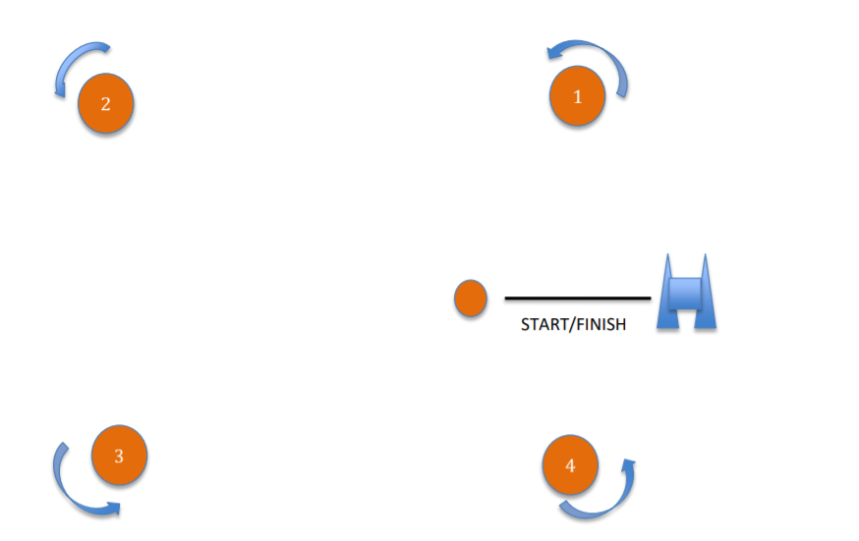
- Marks - Marks 1 to 4 will be large orange cylindrical type inflatable buoys. Replacement marks as provided in RRS 34 will be large orange or yellow cylindrical type inflatable buoys.

- The Start
  - The Start Line - The start line is defined as the line between the flagstaff on the Committee Boat flying an orange flag and an outer starting line mark, normally of the orange inflatable cylindrical type.
  - A boat starting later than four minutes after her start signal will be scored ‘DNS’. This changes Rule A4.1.

- Change Of Course After The Start – To change the next leg of the course, the race committee will move the original mark to a new position.
Signalling the direction of change: RRS 33 (a) (2) is changed: a green or red flag will be displayed from a Rib, stationed at the mark previous, accompanied by a sound signal to indicate that the mark has been moved to starboard or port.

- The Finish - The finishing line will be between the flagstaff displaying an orange flag on the Committee Boat and the finish line mark, normally of the orange inflatable cylindrical type. The race will finish when Code Flag S is flown with two sound signals. Fleets may be separated and average lap times will be used.

- Time Limit - The time limit for a boat will be 10 minutes after the first boat finishes after a valid start, except that if the first boat fails to finish with 1 hours of a valid start, the race will be abandoned. The RO will have the discretion to award a finish to boats given there position on the course.

- Protests
17.1 A competitor intending to protest shall inform a member of the Race committee on the Committee boat or a Rib/Support board before commencing another race or heading ashore.
17.2 Protests shall be written on forms available on request to the Race Committee or on the Open Meeting notice board and delivered to a member of the Race Committee within one hour of the last boat finishing the last race of the day.
17.3 A schedule of protest hearings will be displayed on the official notice board within 2 hours of the finish of the last race of the day. Further protest hearings may be added to the schedule. This is the notice under RRS 63.2.
17.4 All protests shall be open to all sailors for the benefit of learning the rules of sailing.

- Scoring – Will be as the notice of race. 8-9 races completed 2 discards, 5-6 races completed 1 discard fewer that 5 races no discards

- Prizes - Prizes will be awarded for each member of the crews for places as determined by the event organising team based on the entry to the event.

- Radio Communications - A boat shall neither make a radio transmission while racing nor receive radio communications not available to all boats. This restriction also applies to mobile phones.

- Rights to Use Name and Likeness – Competitors automatically grant to the organizing authority without payment the right in perpetuity to make, use and show any motion pictures, still pictures and live, taped or filmed television of or relating to the event.

- Appendix P will apply.

