- Rules
  - The regatta will be governed by the ‘Rules’ as defined in Racing Rules of Sailing, the prescriptions of the RYA, the rules of the class, except if any of these are changed by these sailing instructions, and the supplementary sailing instructions.

- Entries
  - Eligibility - Eligible boats may be entered by completing registration with the organising authority as in the supplementary sailing instructions.
2.1.1 Competitors shall be under 19 on the 31st December 2019 for Youth Classes and under the age of 16 on the 31st December 2019 for Junior Classes. In the case of double handed boats all members must be within the age group above. In the case of Junior double handed boats both helm and crew must comply with the above age group or sail in the youth group.

  - Disclaimer of Liability - Competitors participate in the regatta entirely at their own risk. See Rule 4, Decision to Race. The organising authority will not accept any liability for material damage or personal injury or death sustained in conjunction with or prior to, during or after the regatta.
  - Insurance - Each participating boat shall be insured with valid third party liability insurance with a minimum of £2,000,000 per event.

- Notices to Competitors - Notices will be posted on the official notice board located in the clubhouse lobby.

- Changes to Sailing Instructions - Any changes to the sailing instructions will be posted at least 2 hours before the start of a race they affect, except that any change in the schedule of races will be posted by 20.00 hours on the day before it will take effect.

- Safety - RRS40 is changed, flag Y will not be used. Adequate personal flotation devices must be worn by all competitors whilst afloat. Wetsuits or drysuits are not sufficient on their own.

- Signals Made Ashore
  - Signals made ashore will be displayed on the flagstaff in front of the clubhouse.
  - When Flag AP is displayed ashore, ‘one minute’ is replaced with 'not less than 30 minutes’ in race signal AP. This changes the Race Signals in the Rules.

- Declaration - A declaration system will operate where competitors will be required to sign on and sign off on the form provided and situated near the top of the club slipway or in the Bosun’s hut. All boats must sign off within one hour of the completion of the last race of the day. Boats must sign off separately for each race completed, or indicate “Did Not Start” (DNS) or “Did Not Finish” (DNF) as appropriate. Failure to sign on and off will result in a penalty to be determined by the organising committee.

- Schedule of Races
  - The schedule of races will be stated in the notice of race and the supplementary sailing instructions.
  - When more than one race (or sequence of races for two or more classes) is scheduled for the same day, the warning signal for each succeeding race will be made as soon as practicable. To alert boats that another race or sequence of races will begin soon, the postponement signal will be displayed for at least four minutes before the warning signal is displayed.

- Class Flags - The class flag for the Regatta will be Code Flag Y.

- Racing Area - The racing area is located to the south of the clubhouse.

- The Course
  - Unless otherwise stated in the supplementary sailing instructions the course configuration and order of rounding of marks will be as follows:
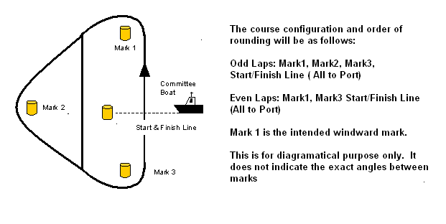

  - Number of Rounds - The number of rounds to be sailed may be displayed on a board on the Committee Boat before the preparatory signal. This changes RRS 27.1
  - Magnetic Bearing of Mark 1 - The approximate magnetic bearing of Mark 1 from the midpoint of the start line may be displayed on a board on the Committee Boat before the warning signal.

- Marks - Marks 1, 2 and3 will normally be large orange or yellow cylindrical type inflatable buoys. Replacement marks as provided in RRS 34 will be large orange or yellow cylindrical type inflatable buoys.

- The Start
  - The Start Line - The start line is defined as the line between the flagstaff on the Committee Boat flying an orange flag and an outer starting line mark, normally of the orange inflatable cylindrical type.
  - A boat starting later than four minutes after her start signal will be scored ‘DNS’. This changes Rule A4.1.

- Change Of Course After The Start - A change of course after the start will be signalled before the leading boat has begun the leg affected although the moved mark may not then be in position. Any mark to be rounded, after rounding the moved mark, may be relocated to maintain the original course configuration. As an addition to RRS 33, a green or red flag may be displayed to indicate that the mark has been moved to starboard or port.

- Shortened Course – The race may be shortened at any mark of the course by a boat displaying Code Flag S. Once the mark has been rounded, competitors will sail straight to the finish line.

- The Finish - The finishing line will be between the flagstaff displaying an orange flag on the Committee Boat and the finish line mark, normally of the orange inflatable cylindrical type.

- Time Limit - The time limit for a boat will be 20 minutes after the first boat finishes after a valid start, except that if the first boat fails to finish with 2 hours of a valid start, the race will be abandoned.

- Protests
  - Protests shall be written on forms available on request to the Race Committee and delivered to a member of the Race Committee within one hour of the last boat of her class finishing the last race of the day.
  - A schedule of protest hearings will be displayed on the official notice board within 2 hours of the finish of the last race of the day. Further protest hearings may be added to the schedule. This is the notice under RRS 63.2

- Scoring - Each boat’s series score shall be the total of her race scores, with her worst score discarded if five or more races have been completed. If five races or less are completed, a boat’s score will be the total of her race scores.

- Prizes - Prizes will be awarded for each member of the crews for places as determined by the event organising team based on the entry to the event.

- Radio Communications - A boat shall neither make a radio transmission while racing nor receive radio communications not available to all boats. This restriction also applies to mobile phones.

- Appendix P will apply.

