- Rules
  - The regatta will be governed by the ‘Rules’ as defined in Racing Rules of Sailing, the prescriptions of the RYA, the rules of the class, except if any of these are changed by these sailing instructions, and the supplementary sailing instructions.

- Entries
  - Eligibility - Eligible boats may be entered by completing registration with the organising authority as in the supplementary sailing instructions.
  - Disclaimer of Liability - Competitors participate in the regatta entirely at their own risk. See Rule 4, Decision to Race. The organising authority will not accept any liability for material damage or personal injury or death sustained in conjunction with or prior to, during or after the regatta.
  - Insurance - Each participating boat shall be insured with valid third party liability insurance with a minimum of £2,000,000 per event.
  - The committee strongly urges you to register for Barts Bash yourself online for the event
  - Donations and registration may be made in the Club, dinghy park or online at https://www.bartsbash.com

- Notices to Competitors - Notices will be posted on the official notice board located in the clubhouse lobby.

- Changes to Sailing Instructions - Any changes to the sailing instructions will be posted at least 2 hours before the start of a race they affect, except that any change in the schedule of races will be posted by 20.00 hours on the day before it will take effect.

- Safety - RRS40 is changed, flag Y will not be used. Adequate personal flotation devices must be worn by all competitors whilst afloat. Wetsuits or drysuits are not sufficient on their own.

- Signals Made Ashore
  - Signals made ashore will be displayed on the flagstaff in front of the clubhouse.
  - When Flag AP is displayed ashore, ‘one minute’ is replaced with 'not less than 30 minutes’ in race signal AP. This changes the Race Signals in the Rules.

- Declaration - A declaration system will operate where competitors will be required to sign on and sign off on the form provided and situated near the top of the club slipway or in the Bosun’s hut. All boats must sign off within one hour of the completion of the last race of the day. Boats must sign off separately for each race completed, or indicate “Did Not Start” (DNS) or “Did Not Finish” (DNF) as appropriate. Failure to sign on and off will result in disqualification.
    - Ladies Race – Please sign on using both the pink declaration sheet and the club declaration sheet if you wish your points to be included in the Club series.
    - Barts Bash – Cadets – Committee Boat Start - Please sign on using the Cadet Barts Bash declaration sheet
- Barts Bash – Cadets – Inshore Course - Please sign on using the blue Junior INSHORE Barts Bash declaration sheet.

- Schedule of Races
date | race title | start time | start format | course format
Saturday 14th September | Ladies Race/ Autumn Saturday 4 | 11:30 | Mass Start | special course
 | Autumn Saturday 5 | A.S.A.P. after ASa4 | class starts | normal courses
Sunday 15th September | Barts Bash / Autumn Sunday 3 | 12:30 | Mass Start | special course
 | Barts Bash Cadet | 12:30 | Mass start | special course 2
 | Autumn Sunday 4 | A.S.A.P. after ASu3 | class starts | normal courses

- Class Flags – Flags are as per Club SI’s for Trophy races and club races respectively.

- Racing Area - The racing area is located to the south of the clubhouse.

- The Course
  - For the usual racers and more experienced juniors and cadets we recommend you join the offshore committee boat course, however for the less experience sailors an inshore course will be set from the shorebox. Unless otherwise stated in the supplementary sailing instructions the course configuration and order of rounding of marks will be as follows:

  - Ladies Race and Barts Bash Committee Boat – Offshore Course (1st races on Saturday and Sunday)
The course will consist of a start/finish gate at the committee boat, a windward mark, a spreader mark and a leeward mark. The gate must only be passed through on the windward leg.
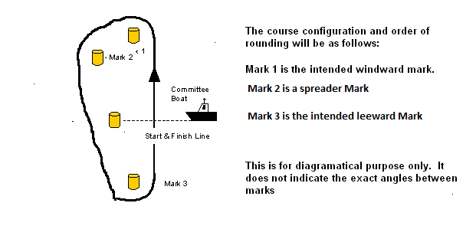

  - Barts Bash Junior Inshore Course – Sunday 15th September 2019 – a start finish gate between the temporary committee boat, and a mark, the course will consist of a trapezoid course, all marks to be rounded to port.

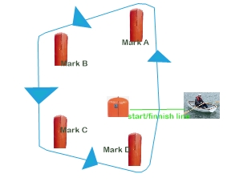

  - Number of Rounds - The number of rounds to be sailed may be displayed on a board on the Committee Boat before the preparatory signal. This changes RRS 27.1

- Marks
  - Offshore Course - Marks 1, 2 and 3 will normally be large orange or yellow cylindrical type inflatable buoys. All marks to be rounded to Port Replacement marks as provided in RRS 34 will be large orange or yellow cylindrical type inflatable buoys.
  - Inshore Course – Marks A,B,C & D will be pencil marks, the start/ finish line will be a line between the temporary committee boat and another buoy.

- The Start –
  - Offshore course - The start line is defined as the line between the flagstaff on the Committee Boat flying an orange flag and an outer starting line mark, normally of the orange inflatable cylindrical type.
  - Inshore Course – The start line is defined as the line between the temporary committee boat flying an orange flag and another mark.
  - A boat starting later than four minutes after her start signal will be scored ‘DNS’. This changes Rule A4.1.

- Change Of Course After The Start - A change of course after the start will be signalled before the leading boat has begun the leg affected although the moved mark may not then be in position. Any mark to be rounded, after rounding the moved mark, may be relocated to maintain the original course configuration. As an addition to RRS 33, a green or red flag may be displayed to indicate that the mark has been moved to starboard or port.

- Shortened Course – The race may be shortened at any mark of the course by a boat displaying Code Flag S. Once the mark has been rounded, competitors will sail straight to the finish line.

- The Finish

  - Offshore Course -The finishing line will be between the flagstaff displaying a blue flag on the Committee Boat (Offshore Course) and the finish line mark, normally of the orange inflatable cylindrical type.
  - Inshore Course - -The finishing line will be between the flagstaff displaying a blue flag on the temporary committee boat (Inshore course) and a mark.

- Time Limit - The time limit for a boat will be 30 minutes after the first boat finishes after a valid start, except that if the first boat fails to finish with 2 hours of a valid start, the race will be abandoned.

- Protests
  - Protests shall be written on forms available on request to the Race Committee and delivered to a member of the Race Committee within one hour of the last boat of her class finishing the last race of the day.
  - A schedule of protest hearings will be displayed on the official notice board within 2 hours of the finish of the last race of the day. Further protest hearings may be added to the schedule. This is the notice under RRS 63.2

- Scoring – Scoring will be on an average lap basis using club and PY numbers.

- Prizes - Prizes will be awarded for each member of the crews for places as determined by the event organising team based on the entry to the event.

- Radio Communications - A boat shall neither make a radio transmission while racing nor receive radio communications not available to all boats. This restriction also applies to mobile phones.

- Appendix P will apply.

