Notice of Race + Supplementary Sailing Instructions

Thorpe Bay Regatta 26th-28th May 2018

Incorporating the Chris Hull Memorial Trophy

To be held at: Thorpe Bay Yacht Club, 115 Thorpe Bay Gardens,
Southend-on-Sea, Essex, SS1 3NW
Telephone (01702) 587563

Rules: Racing will be governed by the Racing Rules of Sailing, the prescriptions of the RYA, the class rules, except if any of these are changed by these sailing instructions, the Thorpe Bay Yacht Club Sailing Instructions and these Supplementary Sailing Instructions.

Eligibility and Entry: The regatta is open to boats of all classes. Non Members of Thorpe Bay Yacht Club may enter by completing an entry form available from the website and handed in at the clubhouse main bar area prior to racing.

Fees: There will be no Entry fee.

Briefing: there will be a briefing at 8am on Saturday.

Schedule of Races
Saturday 26th June |  | High Water – 11:14
 | Warning Signal | Time
Race 1 | Fast Asymmetric multihull, fast asymmetric monohull, foiling moths, sprints, slow multihull Code Flag D  Fast and slow monohull 3rd Substitute  Sanhoppers Naval Numeral zero  Cadets code flag Y | 09:30  09:33  09:36  09:39
Race 2 will take place as soon as possible after completion of Race 1, start sequence as above.

Sunday 27th May |  | High Water – 12:04
 | Warning Signal | Time
Race 3 | Sequence as above, first start | 10:00
Race 4 will take place as soon as possible after completion of Race 4, start sequence as above.

Monday 28th May |  | High Water – 12:46
 | Warning Signal | Time
Race 5 Chris Hull Memorial Trophy(fast cats only) | Sequence as above, first start | 10:30
Race 6 will take place as soon as possible after completion of Race 5, start sequence as above.

Courses: The course shall be in the Thames Estuary to the south of the clubhouse, bounded by the coastguard station to the east, the shipping channel to the south and the pier to the west.

The course configuration and order of rounding will be as follows

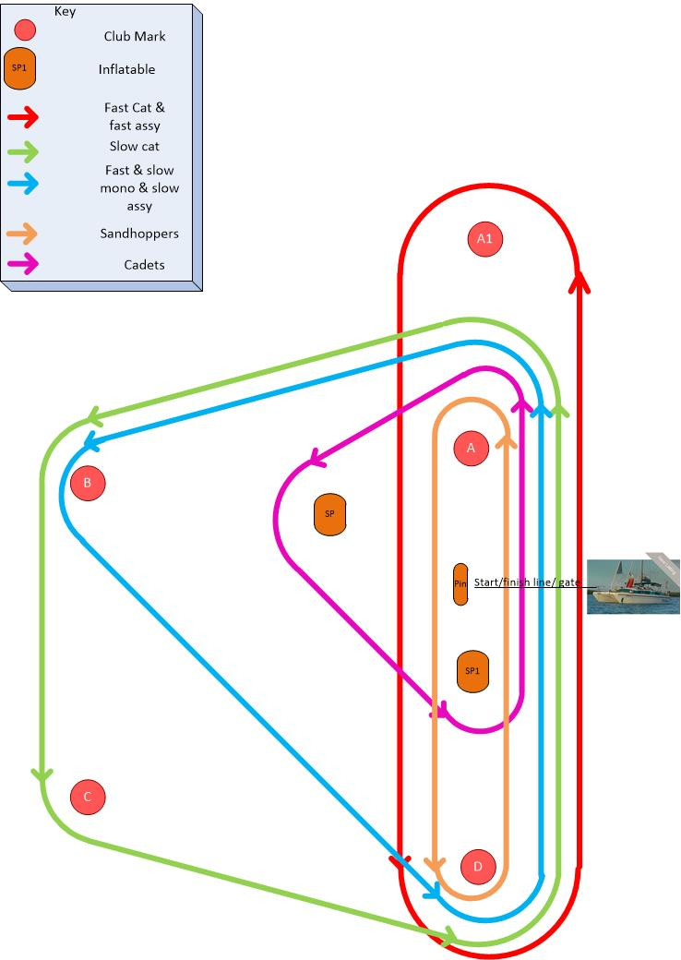

Fast Asymmetric Monohull, Fast Asymmetric multihull, foiling moths:

A1 (Port), D (Port), gate

Sprints and Slow Multihulls:

A (port), B (port), C (port), D (port), gate

Fast Monuhull, Slow Monhull:

A (port), B (port), D (port), gate

Sandhoppers

A (port), D (port), gate

Cadets

A (port), SP(port), SP1(port), gate

Sailing Instructions: These are the standard TBYC sailing Instructions and will be available in the clubhouse main bar area on completion of registration of from the club website.

Scoring: will be the low point system. Each boat’s series score shall be the total of her race scores, with her worst score discarded if five or more races have been completed. If four or less races are completed, a boat’s score will be the total of her race scores.

Disclaimer of Liability: Competitors participate in the regatta entirely at their own risk. See Rule 4, Decision to Race. The organising authority will not accept any liability for material damage or personal injury or death sustained in conjunction with or prior to, during or after the regatta.

Insurance: Each participating boat shall be insured with valid third party liability insurance with a minimum of £2,000,000 per event.

Boat Parking: Boats should be left in the TBYC boat park fronting on to Thorpe Esplanade or as directed by a member of the event organising team.

Car Parking: Cars should be parked in the Southend Corporation Car Park adjacent to the boat park – TBYC car parking stickers will be made available or an area will be roped off, access will be via the dinghy park.

Accommodation: Camping will also be available in the corporation car park. No cars in the boat park please.

Food and Bar Service: Food and drink will be available in the clubhouse on both days. Menus and specials boards will be on display in the clubhouse main bar area along with the times that food will be served.
Saturday Night there will be beer and live music in the clubhouse.

Prize-giving: In the clubhouse as soon as possible after completion of racing on Monday.
Changes to Notice of Race and Sailing Instructions: All changes will be posted at least two hours before the start of the race it will affect, except that any change in the schedule of races will be posted by 20.00 on the day before it will take effect.

Further information can be found at: www.tbyc.org.uk

Or from: Janet Wilsmer, Secretary, Thorpe Bay Yacht Club

Simon.b@talktalk.net
Chris Boshier, Rear Commodore Racing, Thorpe Bay Yacht Club
cbohier@aol.com

