1. Rules
1.1. The regatta will be governed by the ‘Rules’ as defined in the current Racing Rules of Sailing, the prescriptions of the RYA, the rules of the class, except if any of these are changed by these sailing instructions, and the notice of race.

2. Entries
2.1. Eligibility: The Regatta is open to all Sandhopper class boats having a valid measurement certificate.
2.2. Insurance - Each participating boat shall be insured with valid third party liability insurance with a minimum of £2,000,000 per event.

3. Notices to Competitors - Notices will be posted on the official notice board located in the clubhouse lobby.

4. Changes to Sailing Instructions - Any changes to the sailing instructions will be posted at least 2 hours before the start of a race they affect, except that any change in the schedule of races will be posted by 20.00 hours on the day before it will take effect.

5. Safety
5.1 RRS40 is changed, flag Y will not be used. Adequate personal floatation devices must be worn by all competitors whilst afloat. Wetsuits or drysuits are not sufficient on their own.
5.2 Risk Statement. Rule 4 of the Racing Rules of Sailing states: “The responsibility for a boat’s decision to participate in a race or to continue racing is hers alone.” Sailing is by its nature an unpredictable sport and therefore inherently involves an element of risk. By taking part in the event, each competitor agrees and acknowledges that:
5.2.1 They are aware of the inherent element of risk involved in the sport and accept responsibility for the exposure of themselves, their crew and their boat to such inherent risk whilst taking part in the event;
5.2.2 They are responsible for the safety of themselves, their crew, their boat and their other property whether afloat or ashore;
5.2.3 They accept responsibility for any injury, damage or loss to the extent caused by their own actions or omissions;
5.2.4 Their boat is in good order, equipped to sail in the event and they are fit to participate;
5.2.5 The provision of a race management team, patrol boats and other officials and volunteers by the event organiser does not relieve them of their own responsibilities;
5.2.6 The provision of patrol boat cover is limited to such assistance, particularly in extreme weather conditions, as can be practically provided in the circumstances.

6. Signals Made Ashore
6.1. Signals made ashore will be displayed on the flagstaff in front of the clubhouse.
6.2. When Flag AP is displayed ashore, ‘one minute’ is replaced with 'not less than 30 minutes’ in race signal AP. This changes the Race Signals in the Rules.

7. Declaration - A declaration system will operate where competitors will be required to sign on and sign off on the form provided and situated near the top of the club slipway or in the Bosun’s hut. All boats must sign off within one hour of the completion of the last race of the day. Boats must sign off separately for each race completed, or indicate “Did Not Start” (DNS) or “Did Not Finish” (DNF) as appropriate. Failure to sign on and off will result in disqualification.

8. Schedule of Races
8.1. The schedule of races is:

Saturday 28th June |  | High Water – 14.09
Registration from 09.00 |  | Briefing – 10.00 in the clubhouse
 | Warning Signal | Time
Race 1 | Sandhopper Class: NN0 | 11.40
Race 2 will take place as soon as possible after completion of Race 1

Sunday 29th June |  | High Water – 14.44
 | Warning Signal | Time
Race 3 | Sandhopper Class: NN0 | 12.10
Race 4 will take place as soon as possible after completion of Race 3.

9. Class Flags - The class warning signal will be NNO

10. Racing Area - The racing area will be to the South of the Club house.

11. The Course
11.1. The course configuration and order of rounding of marks will be as follows

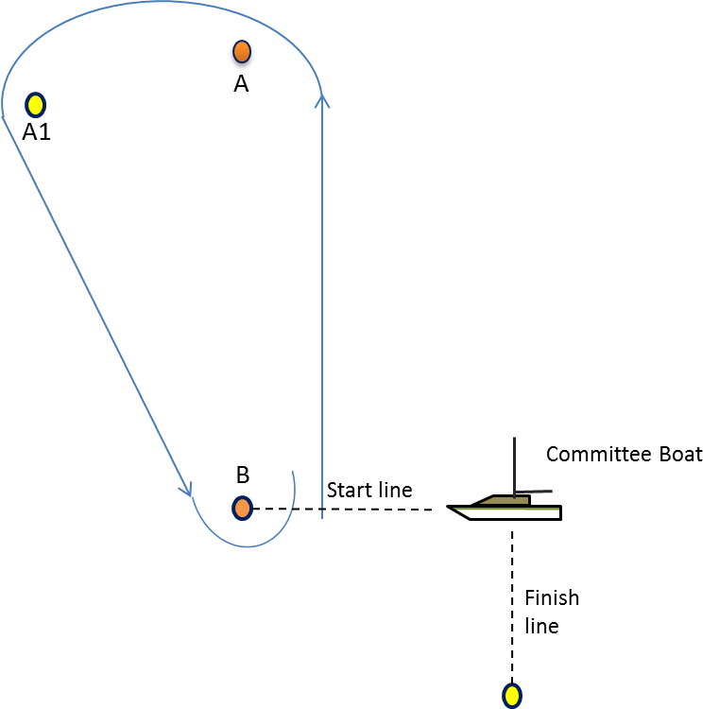
A (port), A1 (port), B (port). This will constitute one round.

After completing the required number of rounds (11.2) proceed to finish (15)

Course diagram not to scale and for information only.

Mark A is the intended windward mark
.
All boats must pass between Mark B and the committee boat on each lap prior to the finish

11.2. Number of Rounds - The number of rounds to be sailed will be displayed on a board on the Committee Boat before the Warning signal.

12. Marks – All Marks will be large cylindrical inflatable buoys. Mark A, A1 and B will be large orange or yellow cylindrical inflatable buoys. Replacement marks as provided in RRS 34 will be large orange or yellow cylindrical inflatable buoys.

13. The Start
13.1. Starting Procedure - The starting procedure will be in accordance with Rule 26. with the warning signal made 5 minutes before the starting signal. (5,4,1,go)
13.2. The Start Line - The start line is defined as the line between the mast on a Committee Boat displaying an orange flag and an outer starting line mark of the orange or yellow cylindrical inflatable type, normally Mark B.
13.3. A boat starting later than five minutes after her start signal will be scored ‘DNS’. This changes Rule A4.1.

14. Changes to the next leg of the course - To change the next leg of the course, the race committee will move the original mark (or the finishing line) to a new position.

15. The Finish - The finishing line will be between the mast on a Committee Boat displaying an orange flag and the finish line mark, normally of the orange or yellow inflatable cylindrical type.

16. Time Limit - The time limit will be 20 minutes after the first boat finishes except that if the first boat fails to finish within 2 hours of a valid start the race will be abandoned.

16.1. For those boats outside the 20 minutes time limit results may be given on their position the previous lap, following on from the results of those who have already finished within the time limit. This is a change to rule 35
17. Protests
17.1. Protests shall be written on forms available on request to the Race Committee and delivered to a member of the Race Committee within one hour of the last boat of her class finishing the last race of the day.
17.2. A schedule of protest hearings will be displayed on the official notice board within 2 hours of the finish of the last race of the day. Further protest hearings may be added to the schedule. This is the notice under RRS 63.2

18. Scoring
18.1. When fewer than three races have been completed, a boat’s series score will be the total of her race scores. When three or more races have been completed, a boat’s series score will be the total of her race scores excluding her worst score.

19. Safety Regulations
19.1. Check out and check in procedures will be through filling in boat name, sail number, helm name and crew name on the declaration sheet in the bosuns hut and completing the form on return to shore.
19.2. A boat that retires from a race shall notify the race committee as soon as possible. The boat shall complete the sign on declaration form in the race box as retired on return ashore.
19.3. Boats not complying with these regulations will be scored DNC

20. Prizes - Prizes will be awarded for each member of the crews for places as determined by the event organising team based on the entry to the event.

21. Replacement of Crew or Helm – Substitution of competitors will not be allowed without prior written approval of the race committee.
The same number of persons shall be on board for all races. Any change of helm from the official entry form will constitute a separate entry in the terms of the overall result for the championship.

22. Equipment measurement and checks – A boat or equipment may be inspected at any time for compliance with the class rules and sailing instructions. On the water, a boat can be instructed by a race committee equipment inspector or measurer to proceed immediately to a designated area for inspection.

23. Radio Communications - A boat shall neither make a radio transmission while racing nor receive radio communications not available to all boats except in case of emergency. This restriction also applies to mobile phones.

24. Right to use name and likeness - By participating in this event, competitors automatically grant to the organizing authority and the event sponsors the right, in perpetuity, to make, use, and show, at their discretion, any photography, audio and video recordings, and other reproductions of them made at the venue or on the water from the time of their arrival at the venue, until their final departure, without compensation.

