To be held at: Thorpe Bay Yacht Club, 115 Thorpe Bay Gardens,
Southend-on-Sea, Essex, SS1 3NW
Telephone (01702) 587563

Rules: Racing will be governed by the ‘Rules’ of Sailing as defined in the current Racing Rules of Sailing, the prescriptions of the RYA, the rules of the class, except if any of these are changed by these sailing instructions and the Supplementary Sailing Instructions.

Eligibility and Entry: The regatta is open to all Sandhopper class boats having a valid measurement certificate. Entry forms will be available in the club house. Entry fee is £20 payable to Thorpe Bay Yacht Club.

Schedule of Races
Saturday 28thJune |  | High Water – 14.09
Registration from 09.00 |  | Briefing – 10:00 in the clubhouse
 | Warning Signal | Time
Race 1 | Sandhopper Class: NN0 | 11.40
Race 2 Will take place as soon as possible after completion of Race 1

Sunday 29th June |  | High Water – 14.44
 | Warning Signal | Time
Race 3 | Sandhopper Class: NN0 | 12.10
Race 4 will take place as soon as possible after completion of Race 3.

Sailing Instructions: These will be available in the clubhouse main bar area on completion of registration.

Venue: The racing area will be to the south of TBYC.

Courses: The course configuration and order of rounding marks will be as follows:

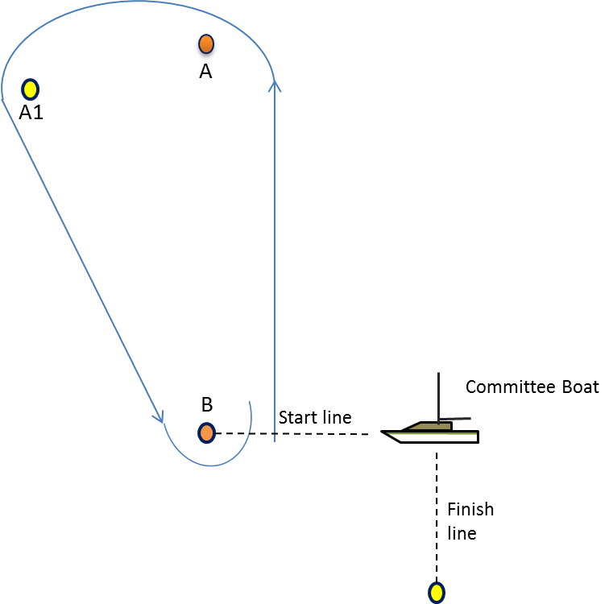
.

A (port), A1 (port), B (port) (This is one round)

After completing the required number of rounds, proceed to finish

Course diagram not to scale and for information only

Mark A is the intended windward mark

All boats must pass between Mark B and
the committee boat on each lap prior to the finish

Scoring: Each boat’s series score shall be the total of her race scores, with her worst score discarded if
Three or more races have been completed. If two or less races are completed, a boat’s score will be the total of her race scores.

Risk Statement: Rule 4 of the Racing Rules of Sailing states: “The responsibility for a boat’s decision to participate in a race or to continue racing is hers alone.” Sailing is by its nature an unpredictable sport and therefore inherently involves an element of risk. By taking part in the event, each competitor agrees and acknowledges that:
- They are aware of the inherent element of risk involved in the sport and accept responsibility for the exposure of themselves, their crew and their boat to such inherent risk whilst taking part in the event;
- They are responsible for the safety of themselves, their crew, their boat and their other property whether afloat or ashore;
- They accept responsibility for any injury, damage or loss to the extent caused by their own actions or omissions;
- Their boat is in good order, equipped to sail in the event and they are fit to participate;
- The provision of a race management team, patrol boats and other officials and volunteers by the event organiser does not relieve them of their own responsibilities;
- The provision of patrol boat cover is limited to such assistance, particularly in extreme weather conditions, as can be practically provided in the circumstances.

Insurance: Each participating boat shall be insured with valid third party liability insurance with a minimum of £2,000,000 per event.

Car Parking: Cars should be parked in the Southend Corporation Car Park adjacent to the boat park – TBYC car parking stickers will be made available. No cars in or in front of the boat park please.

Food and Bar Service: Food and drink will be available in the clubhouse on both days. There is a competitor’s dinner on Saturday night which is not included in the entry fee.

Prize-giving: In the clubhouse as soon as possible after completion of racing on Sunday.

Changes to Notice of Race and Sailing Instructions: All changes will be posted at least two hours before the start of the race it will affect, except that any change in the schedule of races will be posted by 20.00 on the day before it will take effect.

Further information can be found at: www.tbyc.org

