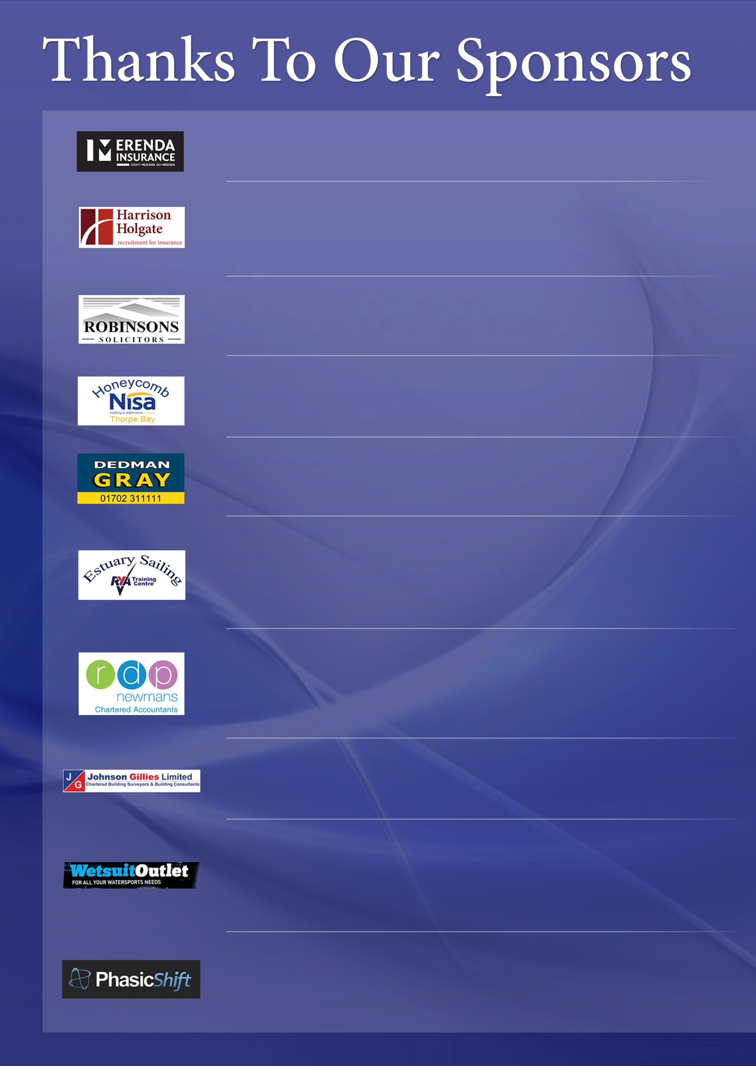
PhasicShift are an experienced team with offices in Southend and London, specialising in Web and Graphic Design but with many years’ experience in both Digital and Print Marketing. Our high quality service and quality of work is reflected by our constant repeat business from existing clients - ranging from business start-ups to corporate companies with turnovers of over £10m.
Working from our own premises we offer the best watersports clothing products from all the top manufacturers. For all your watersports from swimming to surfing to diving, WetsuitOutlet is a one stop shop. From UV rash vests for sun protection, to wetsuit dry suits for thermal protection covering all members of your family and all budgets. We have the latest technology coupled with end of line and past season bargains.
Johnson Gillies are Chartered Building Surveyors who provide professional advice on specific aspects of property acquisition and occupation. We work on the Design and Development of new buildings as well as the restoration and maintenance of existing ones.

We have been helping businesses develop and grow for almost 50 years with our proactive and personal accountancy, business advisory, audit and tax services. We know that our clients work hard to achieve business success and personal financial stability – and our clients know we are working hard to help them achieve the same goals, by providing flexible, forward-thinking advice and services that deliver real value for money.
Estuary Sailing navigation and sea school is an RYA approved training centre. Our aim is to provide top quality, safe tuition at very competitive prices. Courses are run for: RYA shore based theory courses, RYA powerboat courses, RYA sail cruising courses and RYA motor cruising courses. All courses including RYA Yachtmaster MCA preparation and exam are taught aboard MCA coded vessels. We provide theory and practical tuition to high standards in a laid back style.
Dedman Gray are Commercial Property Consultants and Business Transfer Specialists. We specialise in the sale, letting and acquisition of all types of commercial premises, the sale and acquisition of investments, commercial management and the provision of associated professional services.
The Honeycomb Nisa Supermarket is run and operated by its owners and with a friendly team of helpful staff, you can be sure of excellent service and a genuine smile. Honeycomb, in conjunction with NISA, have daily offers and always compete on price and quality with the larger supermarket chains.
Robinsons Solicitors have been based in Ness Road, Shoeburyness, Essex since the 1990’s. We offer a wealth of comprehensive experience in relation to Wills, Probate, Trusts, Lasting Powers of Attorney, Court of Protection, Residential Conveyancing, Commercial Conveyancing, Leases & Tenancy Agreements
Harrison Holgate are specialist insurance industry recruiters focusing on roles within London and the surrounding areas. Combining insurance industry experience with impressive long term success within the insurance and reinsurance recruitment fields, we are committed to providing a dedicated, professional and personalised service.
Merenda Insurance has been established for over 40 years. Our principles have never changed. To give honest, helpful and personal advice and to arrange the policy with the most competitive insurer and the best cover available.

