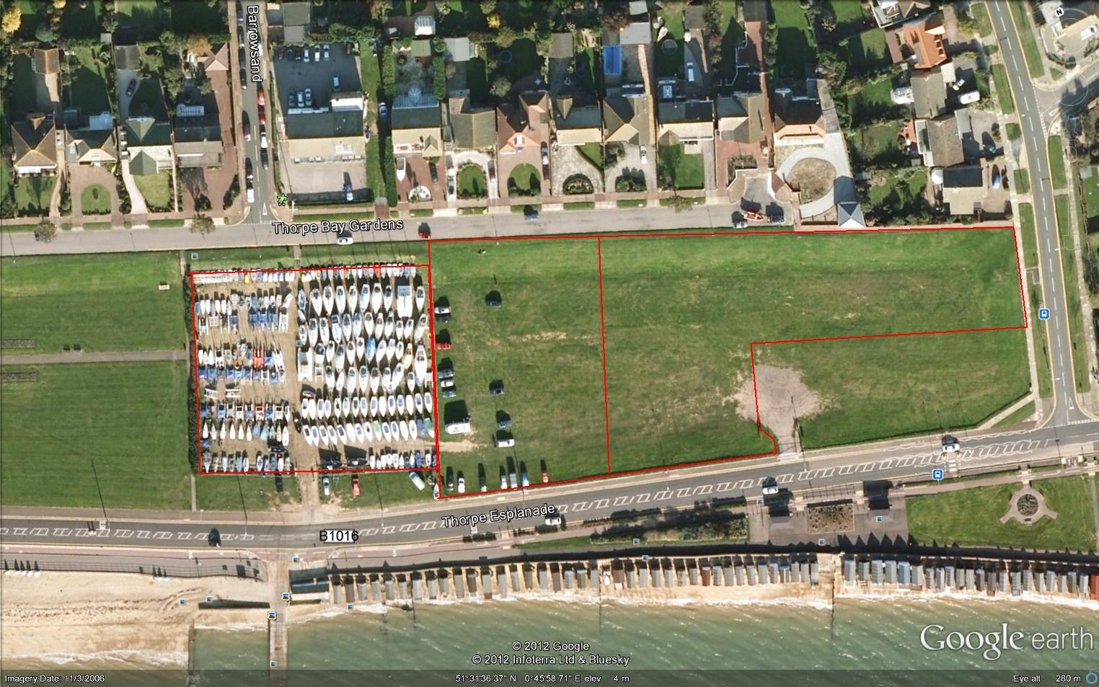

**Parking & Trailers**

**Parking**

**Camping**

**Event Boat Park**

**TBYC EVENT AREA & Camping**

**Launch Area 9er’s**

**Trollys Stacked Against**

**Sea Wall**

**No Parking**

**No Parking**

**TBYC**

Grass Bank